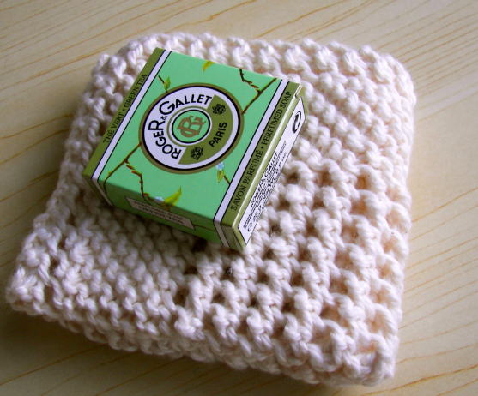
Please referr to http://abuelitasknittingandneedlepoint.com/freepattern.html

